III. Requirements Analysis
The system includes three types of users: Guest, Receptionist, and Administrator. Different users have different permissions and can perform different operations.
Actor | Description | Main Permissions
Guest | Customer who wants to book a room | Register, login, search rooms, view room details, make reservation, pay, view history, cancel reservation, review
Receptionist | Hotel staff who manages daily check-in and check-out | Login, view arrivals/departures, check-in, check-out, walk-in booking, update room status
Administrator | System manager who manages hotel data | Login, manage users, manage staff, manage room types, manage rooms and prices, manage reservations, view reports, manage reviews
3.2 Functional Requirements
The main functional requirements of the system are listed in the table below.
ID | Function | Actor | Description
FR-01 | User Registration | Guest | Guest can create an account with username, password, email, and phone.
FR-02 | User Login | Guest, Receptionist, Administrator | Users can log in and access functions according to their role.
FR-03 | Search Available Rooms | Guest | Guest can search rooms by check-in date, check-out date, room type, and price.
FR-04 | View Room Details | Guest | Guest can view room type, price, capacity, description, and image.
FR-05 | Make Reservation | Guest | Guest can select a room and create a reservation.
FR-06 | Check Availability | System | System checks whether the selected room is available for the selected dates.
FR-07 | Make Payment | Guest | Guest can simulate payment for a reservation.
FR-08 | View Reservation History | Guest | Guest can view past and current reservations.
FR-09 | Cancel Reservation | Guest | Guest can cancel a reservation according to hotel rules.
FR-10 | Write Review | Guest | Guest can submit a rating and comment after check-out.
FR-11 | View Today’s Arrivals/Departures | Receptionist | Receptionist can view guests arriving and leaving today.
FR-12 | Check-in Guest | Receptionist | Receptionist can check in a guest and update room status to Occupied.
FR-13 | Check-out Guest | Receptionist | Receptionist can check out a guest and update room status to Cleaning or Available.
FR-14 | Walk-in Booking | Receptionist | Receptionist can create a booking for a walk-in guest.
FR-15 | Update Room Status | Receptionist | Receptionist can update room status: Available, Occupied, Cleaning, Maintenance.
FR-16 | Manage Users | Administrator | Administrator can add, update, delete, and view users.
FR-17 | Manage Staff | Administrator | Administrator can manage receptionist accounts.
FR-18 | Manage Room Types | Administrator | Administrator can add, update, delete, and view room types.
FR-19 | Manage Rooms and Prices | Administrator | Administrator can manage room numbers, floors, types, and prices.
FR-20 | Manage Reservations | Administrator | Administrator can view, update, and cancel reservations.
FR-21 | View Reports | Administrator | Administrator can view occupancy rate, revenue, and reservation statistics.
FR-22 | Manage Reviews | Administrator | Administrator can view and delete inappropriate reviews.
3.3 Main Interaction Process
- Guest registers and logs into the system.
- Guest enters check-in date, check-out date, and room type.
- System checks room availability and displays available rooms.
- Guest selects a room and creates a reservation.
- System calculates total price and asks for payment.
- Guest completes payment simulation.
- Reservation status becomes Confirmed.
- Receptionist views today’s arrivals and checks in the guest.
- Room status becomes Occupied.
- When guest checks out, receptionist updates room status to Cleaning or Available.
- Administrator views reports such as occupancy rate and revenue
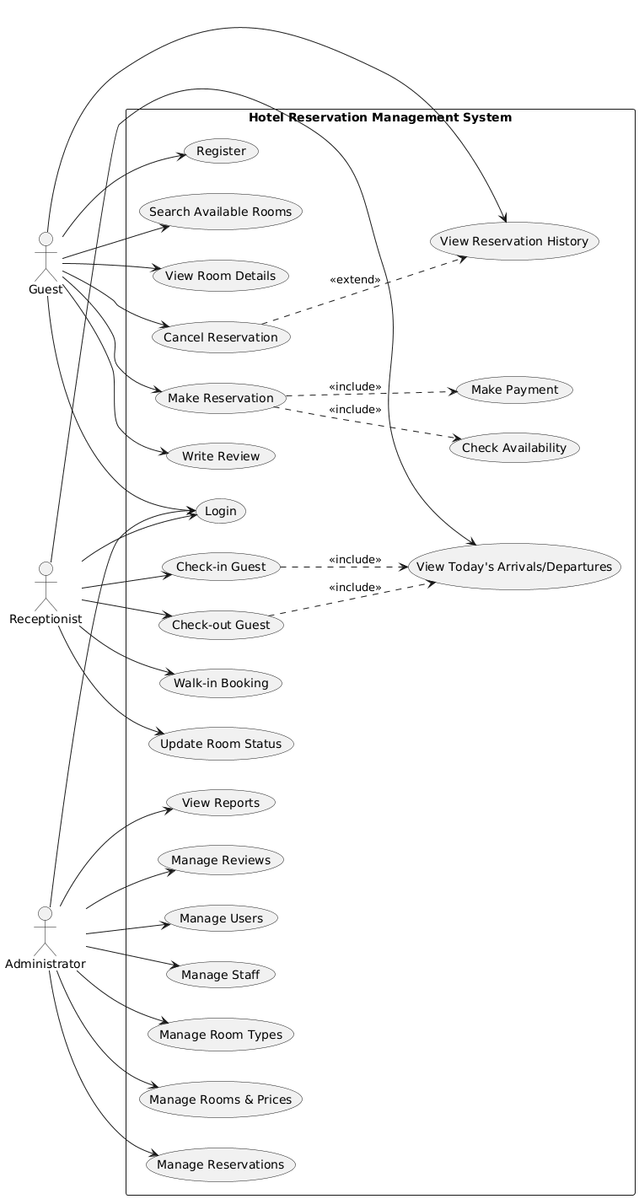
Figure 1 Use Case Diagram of the Hotel Reservation Management System

